**Housing on the Margins**

This post is based on – and somewhat a follow up to – a discussion I had with Max Ghenis of The UBI Center on housing economics and politics. Nolan Gray, an urban planner, had made a quip that the lack of homebuilding in the US has stunted young Americans’ economic futures to the benefit of older homeowners. Max responded that the zoning regulations that suppress home construction actually make older homeowners’ poorer, thus setting off a lengthy debate about the economics of land values, home values, and homeowner politics.

[[LINK TO TWEET THREAD]](https://twitter.com/JosephPolitano/status/1398349339618074627?s=20)

Let me first start where Max and I completely agree – extremely restrictive zoning regulations artificially raise the cost of housing and hamper economic activity. The effects are massive: a recent well-circulated [paper by Chang-Tai Hsieh and Enrico Moretti](https://www.aeaweb.org/articles?id=10.1257/mac.20170388) estimated that tight zoning restrictions in New York City and the San Francisco Bay Area lowered US economic growth by almost 1/3rd between 1964 and 2009. Ending these restrictions would be among the most important policies to encourage economic growth.

So why are we unable to do it? In short, extremely hyperlocal political units decide housing policy in the United States, and these units are often entirely captured by people with vested interest in preventing the construction of new housing. Mayors, city councils, and zoning boards all represent the narrow interests of local existing residents, the most powerful of whom are often high-income, usually white, homeowners. Even in large cities, zoning and land use decisions are subject to byzantine processes of approval with plenty of veto points, ensuring that construction never keeps pace with demand. Existing homeowners and landlords benefit tremendously from this arrangement, as their property values rise as long as supply is constrained and demand increases.

As Max points out, however, the real story is not so simple. If a block of a single-family homes in, say, San Francisco, were to get approval to upzone their properties and construct three-unit triplexes, the homeowners would be able to sell to developers at a handsome profit. Even if a homeowner denied all offers and stubbornly refused to allow their home to be developed, their property value would still rise if upzoning significantly boosted economic output in the area. So, are homeowners rational in zealously opposing upzoning and new construction?

To answer this question, and to build on the discussion I had with Max on twitter, I want to illustrate two points. The first is to distinguish between land, home, and property value and what happens to each of them in the case of a universal upzoning. This was the crux of the disagreement in the twitter thread. Then, I want to discuss the effects of a marginal upzoning of only a select area within a city. This was a subject I did not touch upon in the original thread and I believe it is the most important point in explaining why homeowners so vehemently oppose development.

**Part 1: In Aggregate**

Property, in my definition, is a capital good that represents the sum total of everything purchased when buying a home. Critically, it is a function of two other forms of capital – the land and the home. The land merely represents the legal claim to build whatever is legally allowed on that specific plot. The home represents the physical brick and mortar building that occupies the land. Imagine two examples: an empty plot and a mobile home. In the empty plot, the property is entirely the legal claim to build on the land and has no home. For the mobile home, the property is entirely the physical home itself and has no land. In both examples, the property owner must obtain the missing form of capital in order to produce the final good, shelter. The owner of the empty plot must build a home on their land, and the mobile home owner must buy land to put their mobile home down in.

Since property is a capital good, we will define the value of property as net present value of its marginal product - the property’s current and future rental price - after accounting for risk[1]. In areas where rent is high, property is therefore more valuable. Imagine homeowners as rational agents who seek only to maximize the value of their property (we will drop this assumption in a moment). Would they oppose or support a universal upzoning in their area?

Decomposing their property value into land and home value is critical for this analysis[2]. Firstly, we can unequivocally say that upzoning would lower the current rental price of homes. Zoning prevents new home construction, allowing small, shabby, and old homes to command much higher rents than they would if construction was allowed. Imagine all zoning laws were eliminated in New York City – the infamous decades old shoebox apartments would command lower current rental prices if significant numbers of new units were built. Current land rents, however, become more difficult to parse. While land rents would increase in places where demand allows for the construction of previously banned projects, it is difficult to make statements about land rents in aggregate. Land is a capital input into virtually every good or service’s production, and so estimating aggregate land rents requires knowledge of the production of virtually every good or service. Perhaps land rents would increase as economic activity increases, or perhaps land rents would decrease as land use liberalization allows firms to more easily substitute between land and other types of capital – office buildings, factory floors, etc. The only statement I feel comfortable making is that the effects on land rents would be extremely heterogeneous. Land rents in city centers could skyrocket as people move in from the suburbs, and rents in exurbs could plummet as more people can afford to live closer to the city.

So far, it is not looking like a rational agent seeking to maximize their property value would like this change. Up to this point, however, I have been discussing only the *rents* to property. Since the property *value* is defined in part by expected future property rents, this becomes even more difficult to disentangle. Land use deregulation would certainly boost growth by significant amounts and therefore increase total expected future incomes and expected future land rents. Whether this is enough to make up for the drop in expected future home rents is difficult to know and, again, extremely heterogeneous. I personally find it likely that land use deregulation would result in people spending aggregate lower proportions of their income on property rent as there are diminishing returns to residential square footage. Indeed, that is what we see in Japan, a country held up by urbanists for its relatively lax zoning restrictions.

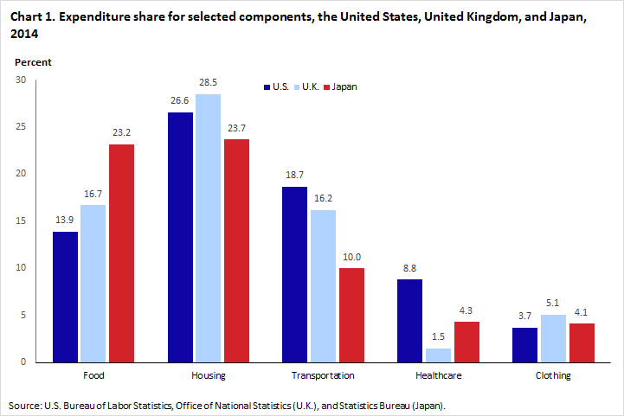

<https://www.bls.gov/opub/btn/volume-6/how-do-united-states-consumer-expenditures-compare-with-the-united-kingdom-and-japan.htm>

But n=1 does not a good data set make, so I will only say that the effects of higher expected future economic growth on current property values is hard to estimate and, again, heterogeneous. Our rational property-value-maximizing agent would see universal upzoning as lowering the current rent of their home, having ambiguous effects on the current rent of their land, and having overall ambiguous effects on the value of their property. They would also see that the effects would be extremely heterogenous among property owners, and would have to determine how their specific property would be affected by the change. There will therefore always be some property owners with a vested interest in preventing universal upzoning, even if the majority of property owners would benefit.

Now, let me relax the idea that homeowners seek only to maximize the value of their property. After all, the majority of homeowners have jobs and investments of their own, and seek to maximize the net present value of all their income, not just their homes. In this case, we know that rational agents would benefit from upzoning’s increased economic growth in the form of increased labor income and higher returns on capital. The effects would, again, be heterogeneous, so there would be some political opposition from people who stand to lose from upzoning. However, it is unquestionable that most people would benefit from increased economic growth and would therefore advocate for upzoning.

So, we’re back where we started. Why do homeowners tend to oppose upzoning?

**Part 2: On the Margin**

This was the most critical point that went unaddressed in my discussion with Max. Rational agents think on the margins, not in aggregate, and on the margin homeowners’ opposition to upzoning makes much more economic sense.

The upzoning of an additional local plot of land has three effects. First, it dramatically increases the land value of the upzoned plot. Now that additional units can be built on the plot, the land rent and expected future land rent dramatically increases. Second, it lowers the value of all homes in the non-upzoned plot. As explained before, existing homes command a much higher rent thanks to zoning restrictions that constrain the supply of homes. We see empirically that the construction of new apartments tends to lower the rents in surrounding areas, meaning that the rental price and the value of nearby homes decreases. Finally, the upzoned plot boosts economic activity and economic growth, increasing current land rents and expected future land rents in surrounding areas. Overall, local property values in areas near the upzoned plot have their home values decreased and their land values increased, leading to ambiguous and heterogeneous effects on property values.

Homeowners will therefore oppose upzonings that lower their home values more than they raise their land values. On the flip side, they will support upzonings that raise their land values more than they lower their home values. In practice, this means that homeowners will support the upzoning of commercial and business areas, which boosts economic growth and land values, while zealously opposing the upzoning of residential areas, which could lower home values. It is no accident that the San Francisco Bay Area consistently adds [more jobs than housing units](https://sf.curbed.com/2017/7/26/16040938/san-francisco-jobs-housing-ratio-homes), as this arrangement is extremely beneficial for existing property owners.

https://twitter.com/IDoTheThinking/status/1399436750838145029?s=20

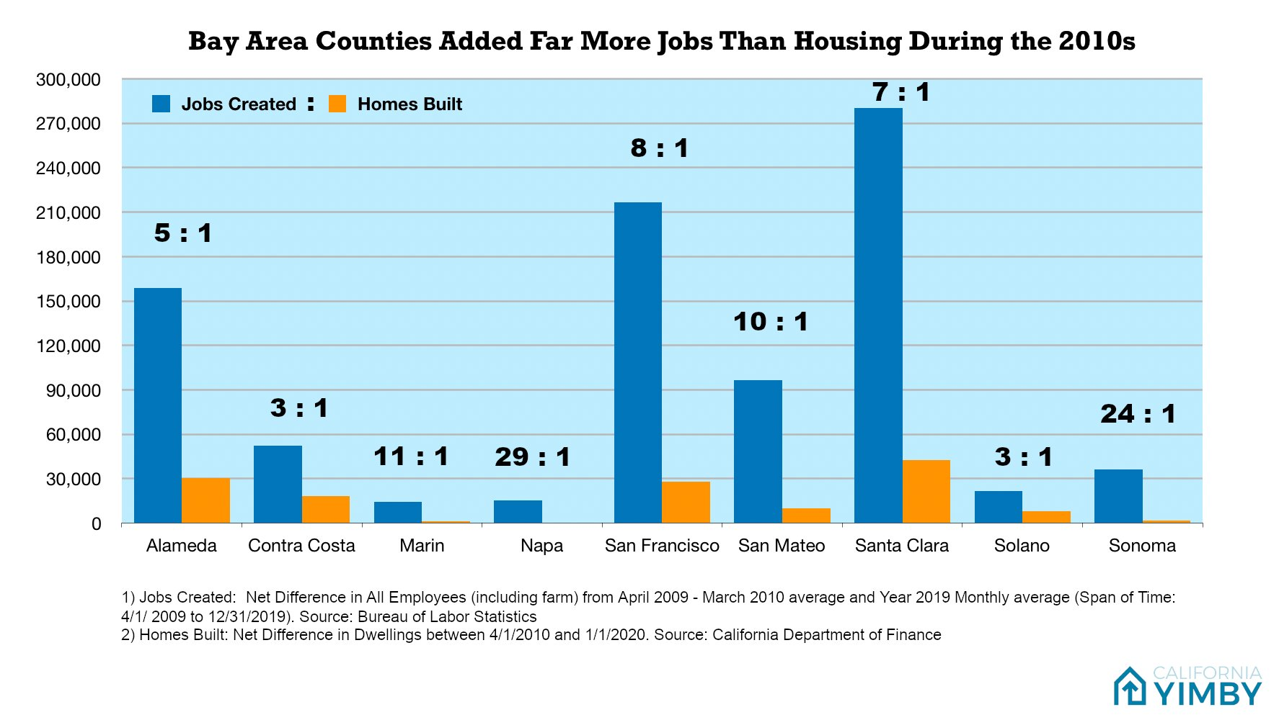

Nationwide, America is locked into this problem where nearly every area’s housing construction does not keep pace with demand. This is the most literal embodiment of NIMBY-ism, the ideology of “Not in my back yard”. Americans would, on aggregate, tremendously benefit from the relaxing of zoning restrictions that prevent construction. However, almost every marginal residential upzoning financially hurts the local homeowners who control the local governmental entities that determine zoning policy. That, to answer Max’s original question, is why rationally self-interested homeowners so zealously oppose new residential construction.

**Part 3: Conclusion**

Constructing an efficient and beneficial market structure requires policymakers to align the marginal individual benefit with the marginal social benefit. In American housing markets, the current relationship works the exact opposite way – residential construction that would benefit society tends to go against the individual interests of existing homeowners. So how can we align the two?

One idea brought up to me by my friend Tom Spencer comes from the UK’s Street Voting community. Essentially, street voting tries to get groups of residents in one area to decide on a uniform zoning rule for the entire community, and allows by-right construction (i.e. construction without the need for a permit approval) for the entire community. The goal is to get all homeowners to solve the local collective action problem – if they would all be better if the locality was upzoned but would oppose any individual upzoning that did not occur on their property, the street voting process would ensure that upzoning would still occur.

While this would be a marked improvement over the current zoning process, I still believe it would be insufficient for fully aligning the incentives of the housing market. Democracy only works when all the views, interests, and opinions of all affected people are represented by the body that designs policy. The residents who would stand to benefit from any new residential construction project are rarely represented by the zoning and planning boards that make decisions about the project, and until they are America will never have enough housing. The only answer, in my opinion, is either to fully eliminate zoning restrictions or to take large parts of zoning and planning control away from local entities and put them into the hands of more representative politicians and agencies on the state and national level. Until that happens, the narrow self-interest of local property owners will dominate the broad benefits of people as a whole.

1. There are other factors that influence property value - user costs, supplemental costs, interest rates, etc. But they can be held constant for the purposes of this exercise.
2. In practice, exactly decomposing property value into home and land values is extremely difficult for many of the reasons that exactly calculating any capital good’s value is difficult – the value of capital is influenced by its marginal product, expected future marginal product, user and supplemental costs, risk, and interest rates. Since shelter cannot be produced without both land and homes, it becomes almost impossible to exactly measure the marginal product of either. This is why I speak only in the directions that rents and value change throughout this discussion.